31st August 2017

**YOKOHAMA’s “GEOLANDAR” to Come Factory-Equipped on New Jeep® Compass in North America**

YOKOHAMA has begun supplying its “GEOLANDAR G055” as original equipment for FCA US LLC all-new Jeep® Compass, which went on sale in North America in June 2017. The new Compass will come factory-equipped with 225/55R18 98H size tyres. In addition, YOKOHAMA’s “GEOLANDAR SUV” is original equipment on the Jeep® Compass that the automaker launched in China in late 2016.

The “GEOLANDAR G055” is an SUV tyre based on the Company’s leading-edge “BluEarth” tyre technology. In addition to delivering the utility performance required for driving on various road surfaces, “GEOLANDAR G055” tyres contribute to the vehicle’s superior fuel-efficiency, comfort and safety. The “BluEarth” technology mark is prominently displayed on the tyre’s sidewall. “GEOLANDAR G055” tyres are targeted at SUVs designed primarily for use on-road, including urban crossover models and small and midsize SUVs, which are popular around the world.

YOKOHAMA is dynamically developing tyres employing its leading-edge “BluEarth” tyre technology, and many of these tyres have been adopted by automakers as original equipment, especially on new eco car and hybrid vehicle models.

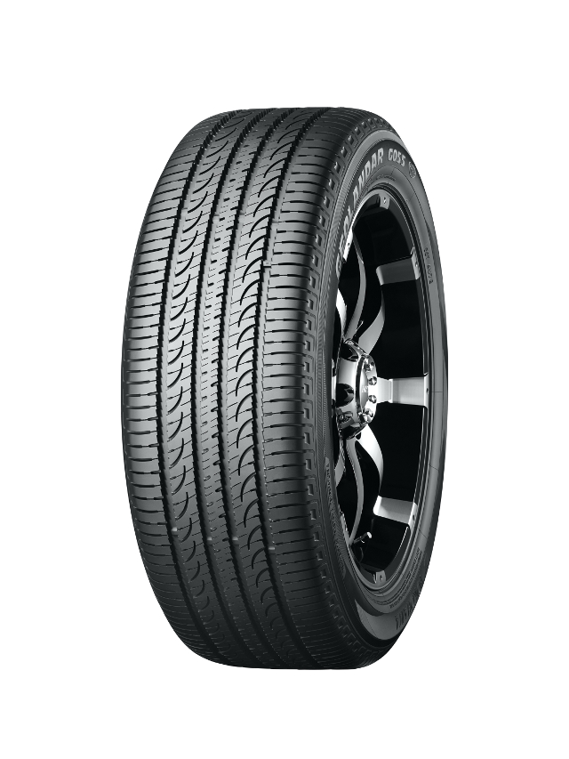

*“GEOLANDAR G055” Tyre shown in photo differs in size from those installed on the Jeep® Compass. (wheels shown are not original equipment)*